Master 3 types of crazy mobile ui swipe interactions
Intro
0:00
If you want to build swipe interactions
0:01
that feel crazy good like this, then
0:04
stick around
0:09
because it's the interactions that turn
0:11
a UI into an experience. So, we'll be
0:14
breaking these down into three broad
0:15
categories. Within page navigation,
0:17
between page navigation, and swipe
0:19
gestures. Let's break it down. Because a
Within Page Navigation
0:21
phone is obviously much smaller than
0:23
desktop, we get to use the edges of the
0:25
display for some pretty unique effects.
0:28
A common starting point is scrolling
0:29
cards. These are better than stacking
0:31
things vertically, but swiping through
0:33
these feels very rigid. Opening up the
0:35
easing curve to give it some more bounce
0:37
makes this feel much more natural,
0:39
allowing the cards to carry more
0:40
momentum. Easing and bounce are
0:42
remarkably important to make lifelike
0:44
interactions. Almost never do you want a
0:46
linear ease. Things in real life speed
0:49
up and slow down. And by playing with
0:51
that curve, we transform animations. It
0:53
also helps provide tone like snappy and
0:56
performant, fun and springy, or slow and
0:58
smooth. But now we can take things a
1:01
step further. Skewing the cards like
1:02
this off the edge of the screen, we give
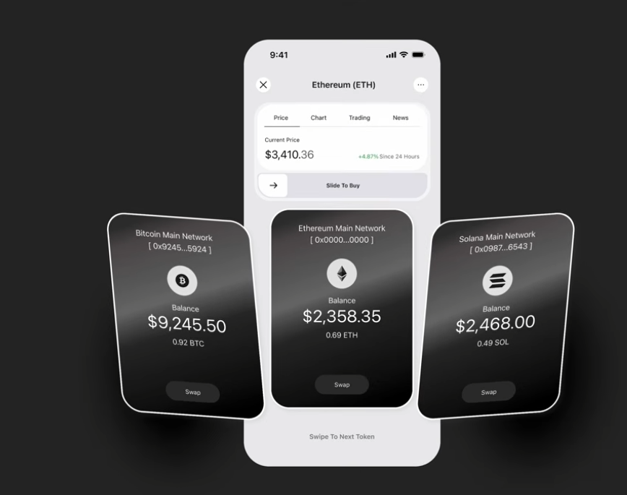
1:04
the effect that we have a
1:05
three-dimensional ring of cards that we
1:07
can swipe through. This looks really
1:09
good so far, but taking into account
1:10
good UX, we should add some indicators
1:12
down here. Now, these can be boring,
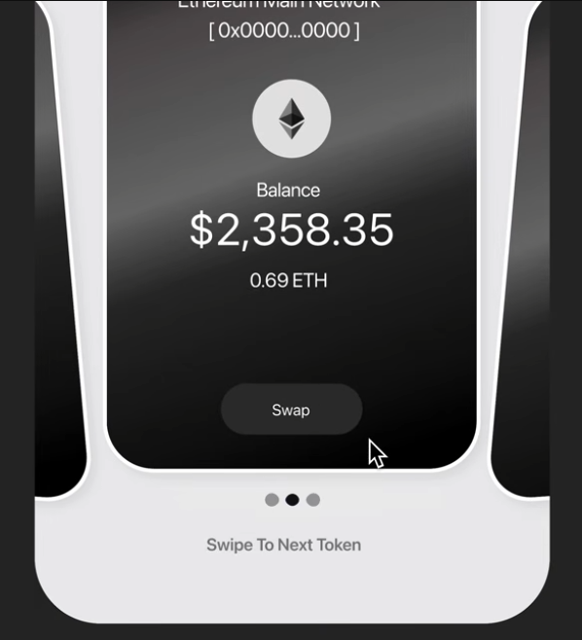
1:14
just highlighting on swipe, or let's add
1:17
a fluid effect on swipe that feels kind
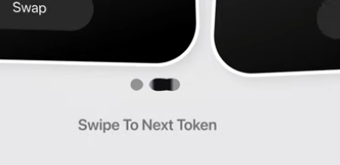
1:19
of magnetic. We'll actually be
1:21
revisiting this cool effect a little
1:22
later in the video. One fantastic use of
1:25
the side of the phone is to treat it as
1:27
a type of horizon that shrinks things
1:29
that get closer to it. Pair it with a
1:31
circular swipe motion and we end up with
1:33
something like this. Just like in the
1:34
previous example, the idea is to provide
1:36
the user with the feeling that they have
1:38
a spool of data that they can access
1:40
with the swipe of their fingers. We can
1:42
also go full screen by swiping down, but
1:44
importantly, we have our black
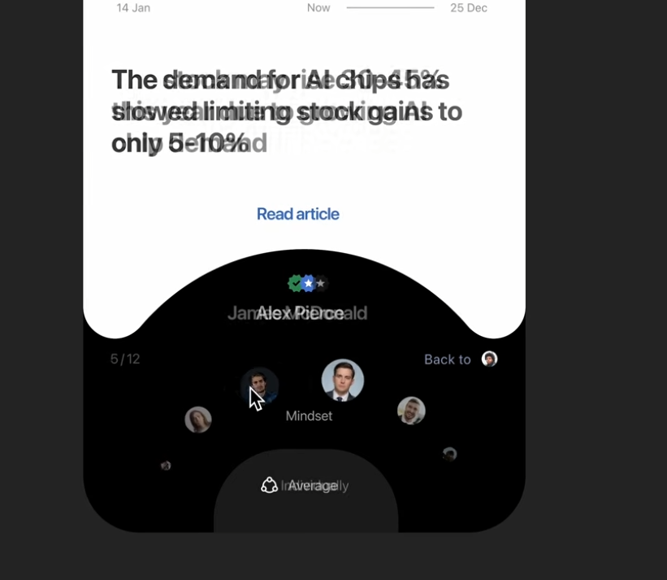
1:46
background that can be clicked or swiped
1:48
to change modes. And that's a common
1:50
duality that you'll see. Swipe
1:51
interactions are readily available and
1:53
intuitive. But for the uninitiated,
1:55
there are also buttons to give the user
1:57
options. For example, in Gmail, we can
1:59
delete by swiping or we can click and
2:02
hit delete, providing multiple ways to
2:04
interact with the same UI. But if you're
2:06
serious about designing like a
2:07
professional, then you should check out
2:09
the sponsor of this video, Zero to
2:10
Mastery. They have a ton of fantastic
2:13
road maps like their UIUX design career
2:15
path which guides you through seven
2:17
courses and 137 hours of instruction to
2:20
take you from complete beginner to
2:22
landing design jobs. With a Discord
2:24
community of over a half a million
2:25
students, you'll be joining a thriving
2:27
community of learners. And there's even
2:29
an accountability channel where you can
2:30
team up with someone to keep you
2:32
motivated. And these aren't just surface
2:34
level courses either. Each one includes
2:35
in-depth video instruction helping you
2:37
build real world practical systems.
2:39
Plus, you'll earn a certificate of
2:41
completion once you finish a course to
2:43
showcase on your resume or portfolio. If
2:45
you're interested, the link and promo
2:47
code will be below to get you 10% off.
Between Page Navigation
2:50
Navigation between pages doesn't need to
2:52
be as lame as this. This could actually
2:54
be a swipe action, but instead, let's
2:56
make it a little more fluid. Instead,
2:58
swiping up will take us to the recipe
3:00
page, but let's slow that down a little
3:02
bit and take a closer look at it. When
3:04
we swipe up, the card underneath expands
3:06
to be the same size as the screen. At
3:08
the same time, the black tab expands to
3:11
also be the entire screen, and then the
3:12
content fades up and in. Finally, we
3:15
complete the fluid look with this
3:16
elastic snap at the very top. The way to
3:19
make these seamless transitions is to
3:20
make the motion feel natural by
3:22
following the direction of the swipe
3:24
with a background and new content
3:26
sliding up and in. This is a principle
3:28
that we'll see in action in the next
3:29
example, too. This is a simple
3:31
onboarding flow, but instead of just a
3:33
button to slide us over, we have a
3:34
button that is clickable or swipeable.
3:36
And by making the motion follow the
3:38
direction of the swipe and then wrap
3:40
around into the next slide, we make it
3:42
super fluid. It might make more sense
3:44
how this works if I zoom out and show
3:46
you everything. We start with a circle
3:47
that expands very large and move the
3:50
content out. Then we swap the circles
3:52
out and shrink that one back down and
3:54
move the new content in. It's actually a
3:56
pretty simple effect when you see it
3:57
like this. Now, those are all well and
3:59
good, but they're fairly complex, but
4:01
even something similar like this is just
4:03
so much better than sliding a new page
4:05
in. This swipe creates continuity
4:07
because we have this image actually
4:08
zooming in to become the new hero image
4:10
and it makes your navigation experience
4:12
just so much more seamless. Finally,
Swipe Gestures
4:14
swipe gestures. These are used to
4:16
provide functionality that could replace
4:18
a button or reveal more context. Apple
4:21
really likes to use these all the time
4:23
in their applications. For example, if
4:25
we had an app like this to create groups
4:27
with friends, we could have a plus
4:28
button here. Or we could have a swipe
4:30
interaction like this to add them using
4:32
the same effect as our first scrolling
4:34
cards indicator. Now, would it probably
4:36
be good UX to have another option like a
4:39
long press to bring up a menu? Probably.
4:41
But once users understand that they can
4:43
swipe, it's generally a much more
4:44
seamless flow and faster way of
4:46
interacting with the app. Another great
4:48
use of gestures is for dismissing
4:50
popovers and pages because it's so quick
4:52
and often intuitive, which is again why
4:54
Apple uses this gesture everywhere.
4:56
Especially for this popup from the
4:58
bottom, it's pretty clear to swipe down.
5:00
Of course, buttons are included just in
5:01
case it's not immediately obvious. But
5:03
what's really adding to the effect is
5:05
the zoom out and move down of the
5:07
background when the popover appears and
5:09
then the opposite movement when we
5:11
dismiss it. Another relatively common
5:13
use of swipe gestures in real
5:15
applications are confirmations. The
5:17
email sender resend uses it to confirm
5:19
sending an email since it's just much
5:21
easier to accidentally click a button
5:23
than it is to slide a slider all the way
5:25
across the page. These are great for
5:27
high impact or irreversible actions such
5:30
as purchasing crypto in this example.
5:32
And that is how you create some of the
5:34
most intuitive and userfriendly swipe
5:36
interactions possible for mobile
5:38
applications. The link to check out Zero
5:40
to Mastery will be the first one down
5:42
below. And I've also put the link to all
5:43
of the assets used in this video down
5:45
there, too. Thanks so much for watching
5:46
and I'll see you in the next one.
5:51
[Music]

